**LEBANESE AMERICAN UNIVERSITY**

**USAID – HIGHER EDUCATION SCHOLARSHIP PROGRAM**

**HES - Volunteering Program Verification Form**

This form is to be used to document volunteering hours. If a student volunteers for multiple organizations, a separate form must be used for each organization. **This form must be turned in by the 28th of each month, the latest.**

I certify that the scholar Mohammad Ali Mazloum completed a total of 3 hours of service at Life Sculptor.

The hours were completed hours as per the below:

Hours # 1 (date) _02/09 - 06/09_ (initials of supervisor) __A.K.___

Hours # 2 (date) _09/09 – 13/09_ (initials of supervisor) __A.K.___

Hours # 0 date) _16/09 – 20/09 (initials of supervisor) __A.K.___

Hours # 0 date) _23/09 – 27/09 (initials of supervisor) __A.K.___

Brief description of the activities the scholar performed or participated in:

I conducted 3 research:  
-Data role in machine learning  
-The machine learning (ML) pipeline  
-Family plays a vital role in the recovery process of individuals dealing with mental health issues

Written feedback about the scholar’s performance:

Mohammed is part of the research team and he do conduct his tasks on time and without any delays or problems

Please rate the overall performance of the scholar at your organization:

|  |  |  |  |
| --- | --- | --- | --- |
|  | Mastery (5) | Proficient (3) | Emerging (1) |
| **Problem solver** | X |  |  |
| **Engaged & Committed** | X |  |  |
| **Open-minded & multicultural** | X |  |  |

Signature

& stamp

__________________________

_

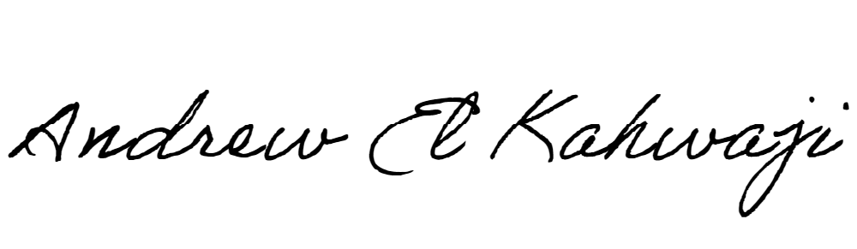

Printed Name _Andrew El Kahwaji_

Date __25/09/2024___

Email __andrew.lifesculptor.coo@gmail.com __

Phone __+961 71 914 378__

**LEBANESE AMERICAN UNIVERSITY**

**USAID – HIGHER EDUCATION SCHOLARSHIP PROGRAM**

